Sierra Bates sjb2206

April 29, 2019

Early Childhood Education: Access and Outcome in New York City.

The goal of this study is to understand if access to early childhood education is limited to wealthy neighborhoods and if it correlates to subsequently higher graduation rates, all within the context of New York City.

In the present study, the following question will be addressed: does funding and access to public early childhood education correlate to high income neighborhoods in New York City? Is early childhood education a privilege of the wealthy? Does this access to early childhood education correlate to academic advancements once children reach adult age?

Typically, wealthier neighborhoods have adequate investments and funding to develop early education which leads to increased access for the members of the community. Early childhood education is correlated with academic success and subsequent attendance of higher education institutions. This research will serve as impactful evidence that access to early childhood education is not a privilege to wealthy neighborhoods in New York City and that other factors may be contributing to varying graduation rates. The simplicity of the proposed visuals will make the data accessible to the general public and can help voters make educated decisions when voting on education budget allocation. The findings of this study can be shared with policy makers on a local and national level to inspire amended budgets to promote development of and access to early childhood education. Unlike prior studies, this analysis not only demonstrates the underlying consequences of the wealth divide and the long term impacts of human educational development.

A study done by the School of Population and Public Health in Vancouver, BC, Canada concluded that the neighborhood you are born to has significant impacts on early childhood development (Minh, 2017). Not only does the physical location have an impact, but rather the attributes of the neighborhood such as income (Minh, 2017). Early childhood development is at a significant deficit to students from impoverished neighborhoods who lack access to early childhood education or socialization. This study does an excellent job of illustrating the cognitive deficits children can be subjected to, however it fails to identify a single element that drives delayed development.

Additionally, research shows that massive differences exist between affluent and poor families in child rearing. A primary example includes extracurricular activity access and participation being significantly lower for children from poor families (Cain, 2015). Divides such as these are deepening the socioeconomic gap between income classes due to inferior cognitive development; therefore, there exists a need to combat this issue. Increasing access to early childhood education has the potential to help bridge this gap and help to decrease the inherent disadvantage of being born to a low-income neighborhood. This study is primarily observational and fails to perform significant statistical analysis. The present study aims to interpret the social implications of these developmental deficits due to income class divides.

The following data were collected for this analysis:

* Income of New York City Neighborhoods
* NYC boroughs and neighborhoods shape files
  + NYC Open Data
* NYC income by neighborhood data
  + US Census
* NYC early childhood education centers location data
  + NYC Open Data
* NYC public high school data pertaining to the total number of enrolled students and the total number of students pursuing higher education following graduation
  + NYC Open Data

A series of three cloropleth maps of New York City were created to supply information regarding average income of neighborhoods, the relative density of early childhood education centers, and graduation rates in boroughs. All maps are shown in the Long Island State Plane projection. The projection plane had to be independently defined for each data set given the original projection was specific to NYC Open Data and not compatible with ArcGIS. Each variable is analyzed and shown on a separate map for clarity in the symbology. A light grey basemap was used on all of the maps for aesthetic appeal.

The primary map used was constructed to illustrate which neighborhoods in New York were the wealthiest. Shapefiles for borough boundaries and neighborhood boundaries were added to the map. An excel containing New York City neighborhood income was obtained and edited to contain only relevant information (for the purpose of this study only median income by neighborhood was needed). The xls file was merged with the neighborhood shapefile after common fields were created to permit the merge. The median income was used for this analysis and the data was normalized as a percentage of the total income for New York City. This map served as a point of reference from which to draw conclusions regarding relationships between early childhood education and wealth divides.

The second cloropleth map, Density of Early Childhood Education Centers in NYC, shows the density of early childhood education locations in each neighborhood in New York. The same shapefiles for neighborhood and borough boundaries were obtained as described above. A shapefile containing points of each early childhood education center was obtained. A spatial join was used to create a graduated map to view the relative density of early childhood education centers normalized over the total. The third map uses the same techniques, except analysis is performed to normalize the number of Early Childhood Education Centers related to the population of each neighborhood.

In efforts to interpret the long term impacts of these findings, a cloropleth map of the percentage of students who attend higher education normalized over the number of high school graduates will also be presented. Only borough boundaries were used in this analysis given the vast zoning for high schools in New York City that are no longer limited to neighborhood boundaries. The same borough boundaries shapefiles were used as described above. An excel file with graduation rate data was collected and edited to only include overall graduation rates for each borough inclusive of both private and public education.

See figures 1-4 below for complete images of the maps produced for this study. Figure 1 illustrates that all of New York City is extremely wealthy, with some neighborhoods such as the Upper East Side and Williamsburg noted to be particularly wealthy. Figure two shows that the distribution of Early Childhood Education Centers is relatively uniform. Figure three illustrates that some neighborhoods have a higher number of Early Childhood Education Centers per population. Figure 4 shows that graduation rates are not drastically different for each borough.

There are limitations to this study. New York City is an inherently affluent region of the world and the data is relative to the surroundings, however cannot be assumed representative of the greater nation or world. The median income data could be skewed by people who sub-let apartments and are not registered New York residents on the census. Additionally, there are confounding variables such as parental involvement and cultural norms that can influence the development of the child beyond the scope of his or her early childhood education program and the affluence of the neighborhood of residence. Data was collected from the most recent and reliable sources available, however not all data was collected within the past calendar year and trends may have changed. Data regarding the percentage of high school graduates per neighborhood was not available and it would be important to see the graduation rates impact on a micro-level.

At a scientific and biological level it is evident that early childhood education and affluence lead to enhanced childhood development. However, this study illustrates that in the context of New York City the differences in childhood development are not correlated with decreased access to early childhood education as a result of wealth disparity. There is fairly equal access to early childhood education for all neighborhoods in New York City and graduation rates are not vastly different between each borough. Moving forward, an in depth analysis should be done regarding graduation rates and involvement/access to in extracurricular activities. These studies would aim to understand the socioeconomic and cultural factors that drive developmental disparities between children.

Works Cited:

Miller, Claire Cain. “Class Differences in Child-Rearing Are on the Rise.” *The New York Times*, The New York Times, 17 Dec. 2015

Minh, Anita, et al. “A Review of Neighborhood Effects and Early Child Development: How, Where, and for Whom, Do Neighborhoods Matter?” *Health & Place*, Pergamon, 18 May 2017

Figures:

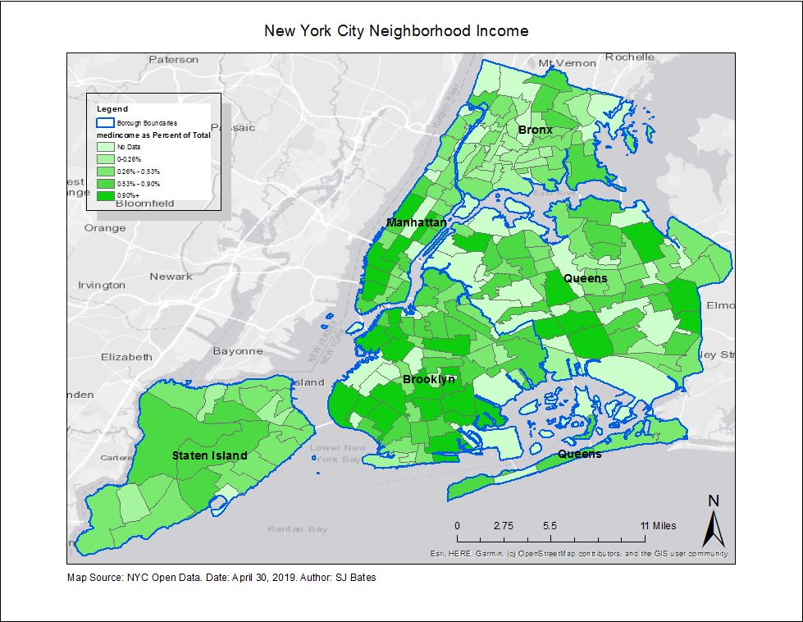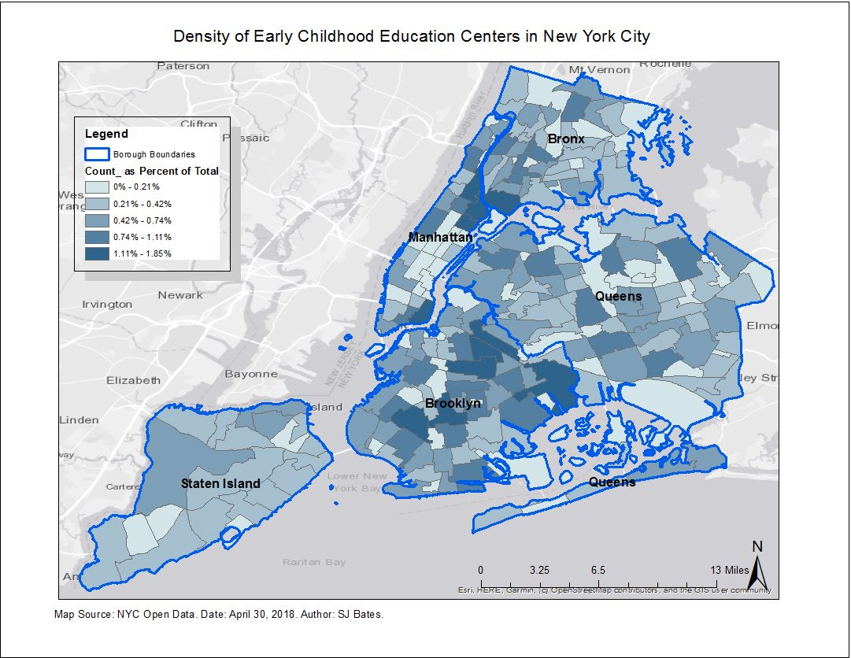

Density of Early Childhood Education Centers Relative to Population

